Module 3.3: Impact of Sea Level Rise on Flooding in Alamitos Bay
Our Coast Our Future Instruction

Follow these steps with your team and use the Our Coast Our Future simulation to explore how flooding is impacted by sea level rise.

- Visit the Our Coast Our Future website. There are a couple of sections that are useful for your investigation.
- Search box is where you can search locations that the map will display.
- Explore Scenarios Menu allows you to set specific conditions for scenarios.
- Legend Key provides information about how to interpret map features using symbols.
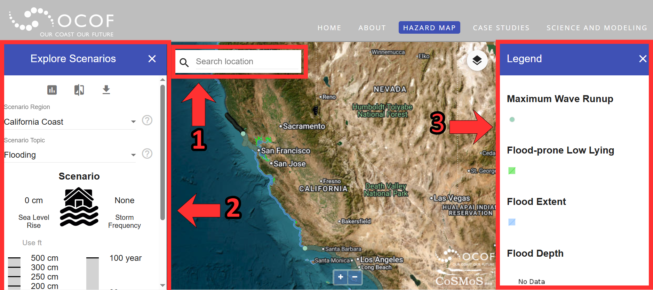
- In the search box, type in and navigate to “Alamitos Bay”. Our investigation will focus on two sections of the map below, Alamitos Bay and Alamitos Beach.
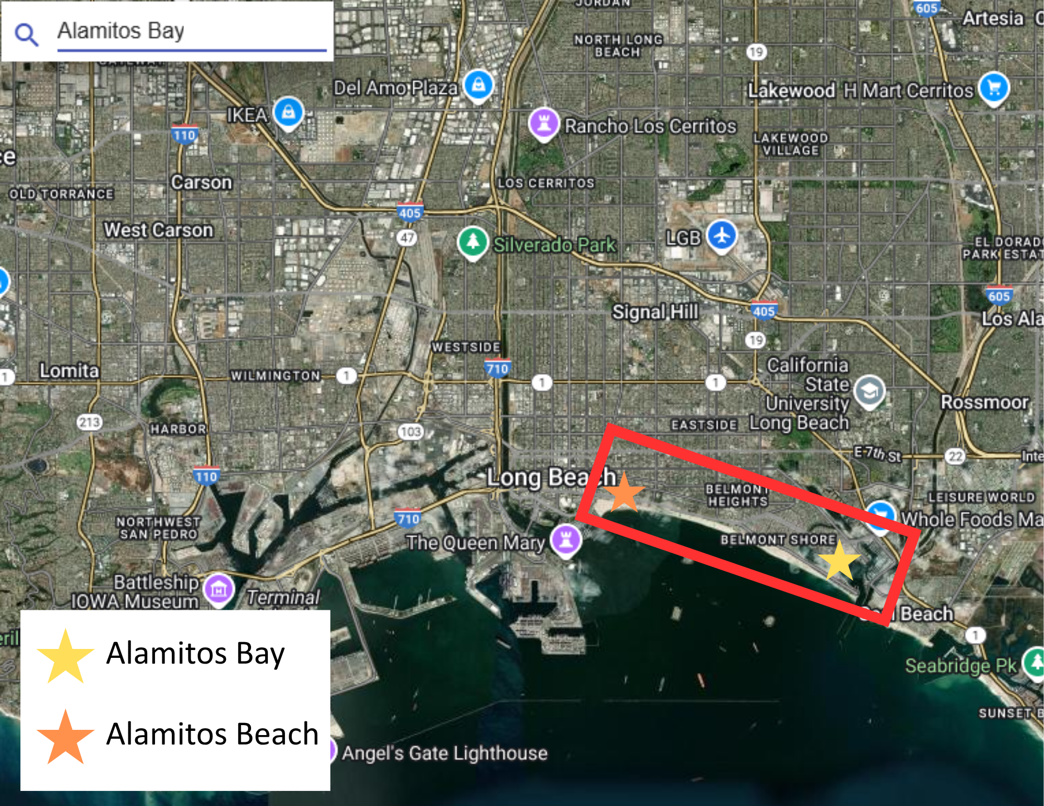

- Move the screen so that you have a better view of Alamitos Bay, like in the image below.

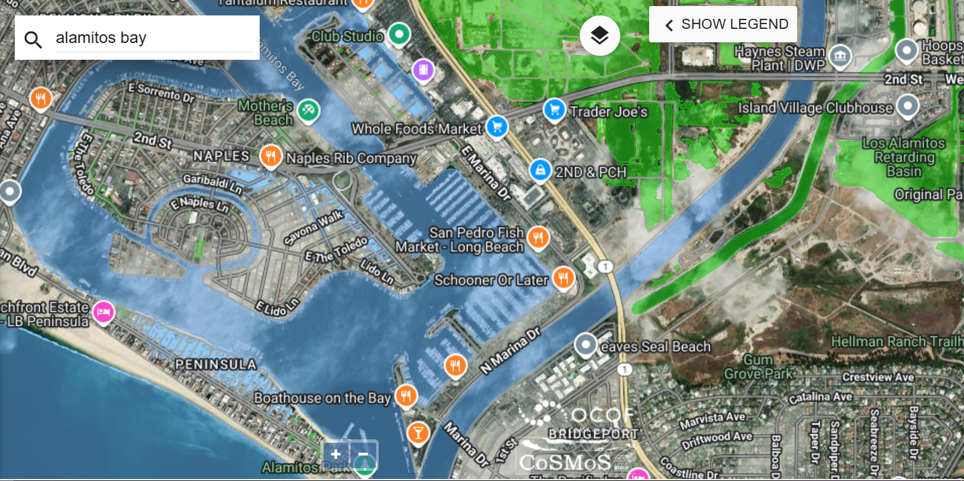

- The first scenario you will explore is how sea level rise impacts flooding in Alamitos Bay. In the Explore Scenarios menu, make sure that the “Scenario Topic” is ‘Flooding’ and “Sea Level Rise” is set to “0 cm”.

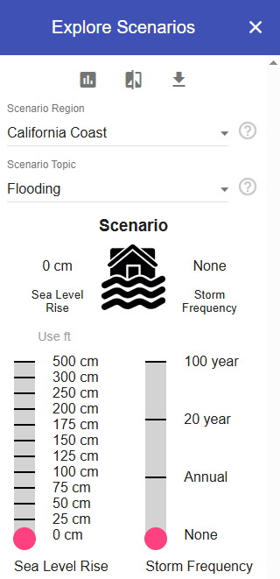

- On the right-hand side menu, use the legend to identify a few features that can help you make observations of Alamitos Bay:
  - Flood-prone low lying areas are locations that are susceptible to flooding.
  - Flood extent shows specific areas covered by water during a flood event.
  - Flood depth indicates how high water rises over land during a flood event.

- As a group take a moment to explore Alamitos Bay and answer the following questions:
  - How is flooding playing a role in Alamitos Bay with 0 cm of sea level rise?
  - How does this flooding impact the community?

- After you’ve made your observation, take a moment to make a prediction with your group on how you think sea level rise might impact spaces like Alamitos Bay.
  - How would sea level rise impact flooding? What impacts would it have on Alamitos Bay?

- Now it’s time to test your prediction. Move to your “Explore Scenarios” section and change sea level rise from “0 cm” to “25 cm”, a projection that is estimated for 2050.

- Once you’ve changed the sea level rise projection, with your group observe the same space in Alamitos Bay and discuss the following questions:
- How has the flood extent changed in Alamitos Bay between “0 cm” and “25 cm”? What is the same? What is different?
- What impact would this flooding have on the community living or recreating near Alamitos Bay? How might it impact the values communities place on the ocean?
- Was your prediction supported?

- Once you’ve made your observations, take a moment to explore an even further prediction to 2100. In the “Explore Scenarios” section, change the sea level rise to “50-100” cm for the 2100 projection and make observations with your group.
  - How does the flood extent change in Alamitos Bay as sea levels are projected to rise?
  - What impact would this flooding have on the community living or recreating near Alamitos Bay? How might sea level rise impact the values communities place on the ocean?

Module 3.3: Sea Level Rise’s Impact on Shoreline Position on Alamitos Beach

- In the search box, type in and navigate to “Alamitos Beach”. Zoom into the beach area. It should look like the following:
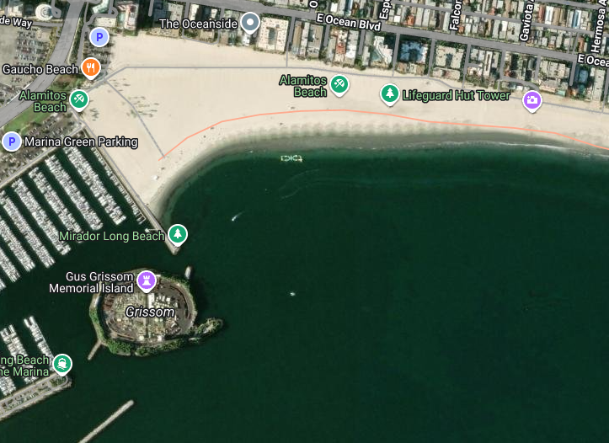

- In the ‘Explore scenarios’ menu, navigate to the dropdown menu under ‘Scenario Topic’. Scroll down and select ‘Shoreline Position’.
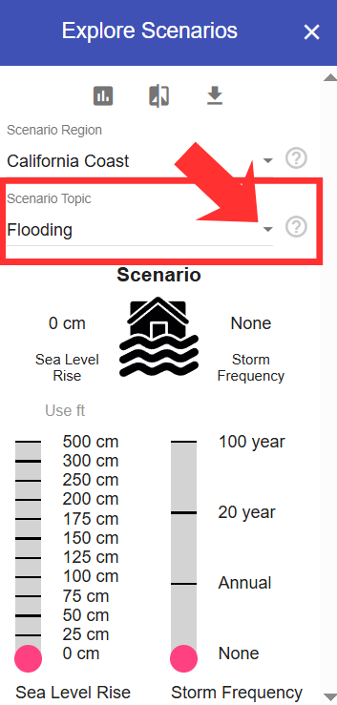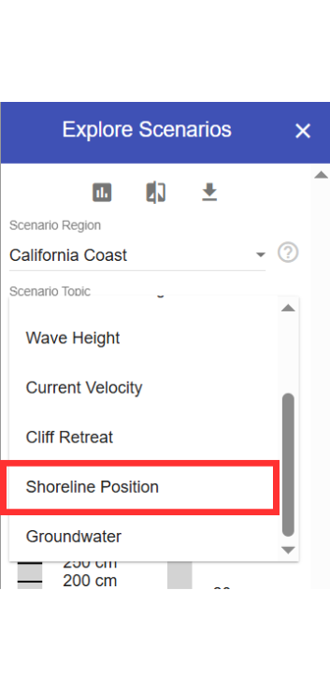

- Next, scroll down to the very bottom of the ‘Explore Scenarios’ menu and locate the option that says “Hold the Line”. Deselect the button next to “Hold the Line” so the bar is grey and no longer active.
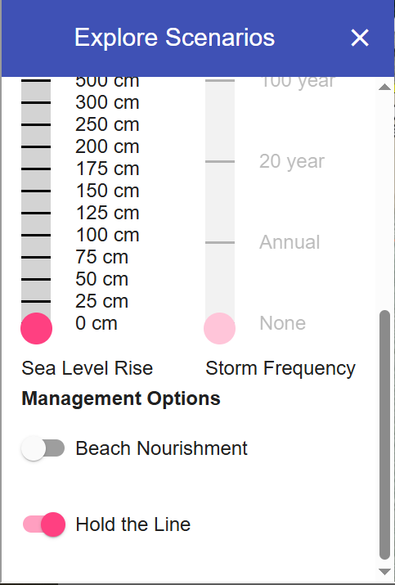 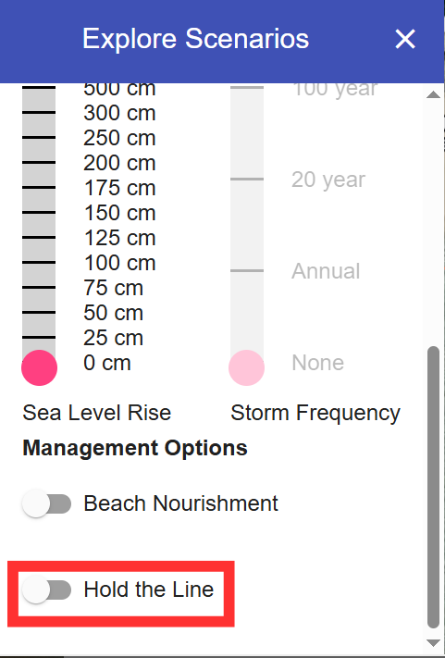

- Navigate to the “Explore Scenarios” menu and make sure the sea level rise is set to “0 cm”.
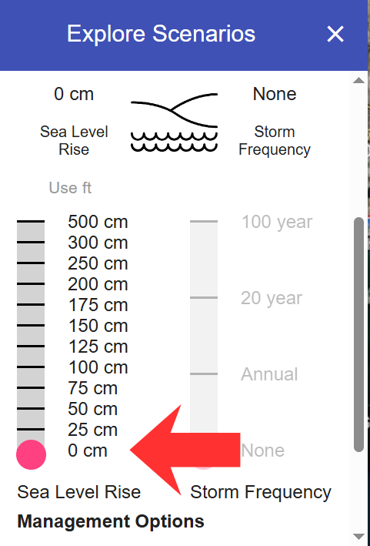

- On the legend on the right-hand side of the screen you will see “Mean Sea Level Shoreline” which will indicate where the shoreline is on your simulation.
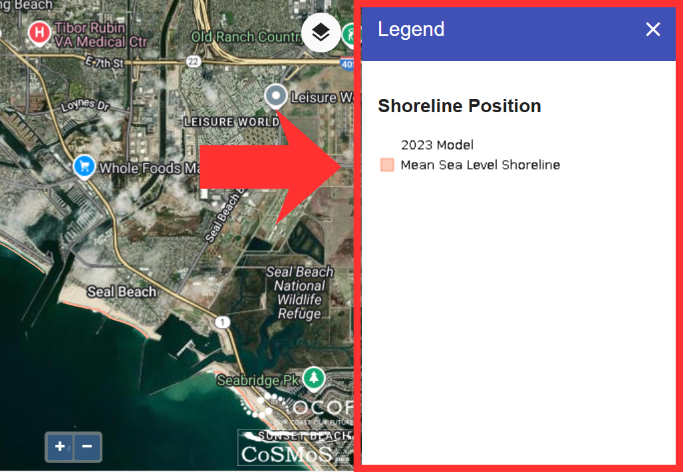

- As a group, take a moment to explore Alamitos Beach and answer the following questions:
- How is the shoreline position playing a role in Alamitos Beach with 0 cm of sea level rise?
- How does the shoreline position impact the community?

- After you’ve made your observation, take a moment to make a prediction with your group on how you think sea level rise might impact spaces like Alamitos Beach.
  - How might the shoreline position change if sea levels were to rise? What impacts would it have on Alamitos Beach?

- Now it’s time to test your prediction. Move to your “Explore Scenarios” section and change sea level rise from “0 cm” to “25 cm”, a projection that is estimated for 2050.

- Once you’ve changed the sea level rise projection, with your group observe the same space in Alamitos Beach and discuss the following questions:
- How has the shoreline position changed in Alamitos Beach between “0 cm” and “25 cm”? What is the same? What is different?
- What impact would this shoreline position have on the community living or recreating near Alamitos Beach? How might it impact the values communities place on the ocean?
- Was your prediction supported?

- Once you’ve made your observations, take a moment to explore an even further prediction to 2100. In the “Explore Scenarios” section, change the sea level rise to “50-100” cm for the 2100 projection and make observations with your group.
  - How does the shoreline position change in Alamitos Beach as sea levels are projected to rise?
  - What impact would this shoreline position have on the community living or recreating near Alamitos Beach? How might sea level rise impact the values communities place on the ocean?

